Name of the Student: G. Manasa | Academic Year: 2025-26
Student Registration Number: 241U1R3007 | Year & Term: II & I
Study Level: UG | Class & Section: CSE-DS-2A
Name of the Course: PYTHON PROGRAMMING | Name of the Instructor: Mr. Pranay Vemula, Assistant Professor, CSE.
Name of the Assessment: Reflective Essay | Date of Submission:

Module-1: Python Basics, Operators and Expressions
Introduction
Python is a programming language. It was created by Guido van Rossum in the 1990s in the Netherlands. The name “Python” was taken from a comedy show called Monty Python, not from the snake. From the beginning, Python was free and open for everyone to use.
Google also started using Python in its early days, which made it very popular. At first, people thought Python was a small language. But later, it grew into a powerful and widely used language. Today, Python is used in making websites, mobile apps, data science, artificial intelligence, machine learning, and many other fields.
Python is easy to read and write, almost like English. Unlike other languages such as C or Java that use { } curly braces, Python uses spaces (indentation) to define code blocks. This makes Python code look neat and clean.

Installing Python
I learned that Python is free and open-source, which makes it easily available for everyone. To install it, I visited the official Python website (python.org) and downloaded the latest version. The installation process was simple, but I also had to take care of some important steps like:
- Selecting the correct version (3.x is preferred).
- Checking the box “Add Python to PATH” during installation.
- Verifying the installation using the command prompt with:
- python --version
These steps taught me the importance of being careful and following instructions. Missing small things, like not adding Python to PATH, can cause errors.
Installing Editors (IDEs and Text Editors)
Next, I learned about editors that help us write and run Python code easily. There are many options, but some of the most popular ones are:
- IDLE: Comes built-in with Python. It is simple and good for beginners.
- PyCharm: A powerful IDE with many features for professional development.
- VS Code (Visual Studio Code): Lightweight, user-friendly, and highly customizable with extensions.
- Jupyter Notebook: Very useful for data science and interactive coding.
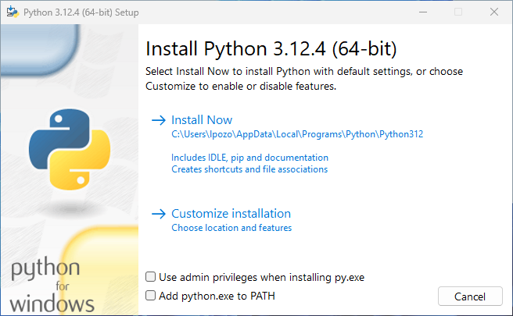
Python Basics
Literal Constants, Variables, and Identifiers
One of the first things I learned was about literal constants—fixed values like numbers (5, 10.5), strings ("Hello"), or booleans (True/False). They are the simplest elements of a program. variables which are like storage boxes in memory where values can be kept and changed during program execution. For example:
x = 10
y = 20
z = x + y
print(z)
Output: 30
Data Types
I learned that every value in Python has a data type. The main ones are:
- Numbers: integers, floats, complex numbers.
- String: for text.
- Boolean: True or False values.
- List, Tuple, Set, Dictionary: to group multiple values.
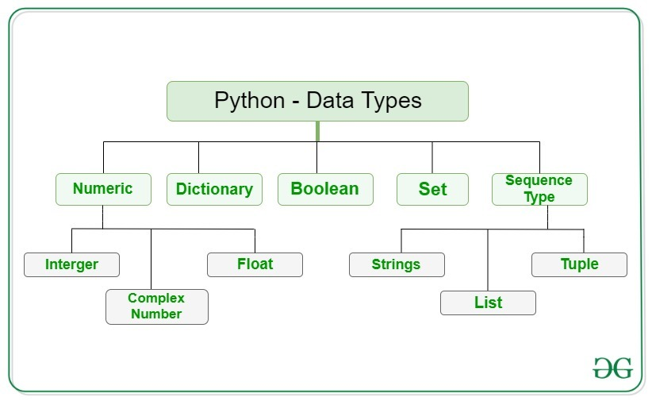
For example:
marks = [85, 90, 95]
student = ("Ravi", 20)
info = {"name": "Ravi", "age": 20}
Input and Output Operations
The input() function allowed me to take information from the user, and the print() function helped me display output. This interaction felt like I was directly communicating with the computer.
Example:
name = input("Enter your name: ")
print("Hello", name)
Comments and Reserved Words
I understood that comments are notes written for humans, not for the computer. They make programs easier to understand and maintain.
Example:
# This program calculates the sum
a = 5
b = 10
print(a + b)
Output: 15
Indentation
Unlike other programming languages that use { } braces, Python uses indentation (spaces) to define blocks of code. At first, I found this strict, but later I realized it keeps the code clean and readable.
Example:
for i in range(1, 4):
print(i)
Operators and Expressions
Arithmetic Operators
I learned that arithmetic operators perform basic math:
- + addition
- - subtraction
- * multiplication
- / division
- ** exponent
- % modulus
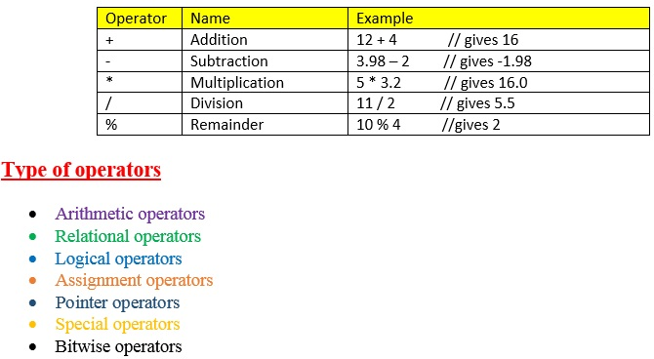
Example:
a, b = 10, 3
print(a + b)
print(a % b)
Comparison / Relational Operators
These operators helped me compare values. They return either True or False.
Examples:
print(5 > 3)
print(10 == 20)
Assignment Operators
Assignment operators store values in variables. I learned shortcuts like:
- x = 5
- x += 3 (means x = x + 3)
- x *= 2 (means x = x * 2)
These shortcuts made coding faster and easier.
Logical Operators
Logical operators allowed me to combine conditions.
- and → returns True if both conditions are true.
- or → returns True if at least one condition is true.
- not → reverses the result.
Example:
a, b = 5, 10
print(a > 2 and b < 15)
Bitwise and Shift Operators
At first, these operators were confusing, but I realized they work on binary numbers.
- & AND
- | OR
- ^ XOR
- << left shift
- >> right shift
Example:
print(5 & 3)
print(5 << 1)
This showed me how computers work at the bit level.

Membership and Identity Operators
I found these very interesting:
- Membership (in, not in) checks if an item exists in a collection.
- Identity (is, is not) checks if two objects are the same in memory.
Example:
print(3 in [1,2,3])
x = [1,2]
y = [1,2]
print(x is y)
Expressions and Operator Precedence
An expression is a combination of variables, constants, and operators.
Example:
a = 10
b = 5
c = (a + b) * 2
Module-II
Selection/Conditional Branching Statements – if, ifelse, Nested if, if elifelse statements Basic Loop Structures/Iterative Statements: while, for, Nested loops, continue, break, pass statements.
Introduction
In this module, I learned about two very important parts of Python programming: conditional statements and looping statements. At first, I felt a little confused because there were many new keywords like if, else, elif, while, for, break, and continue. But after practicing, I understood that these are the main tools that help us control the flow of a program. This made me realize how powerful Python is in solving real-life problems.

Conditional Branching Statements

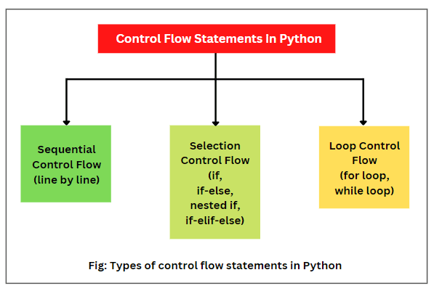
if Statement
The if statement allowed me to run a block of code only when a condition is true.
For example:
marks = 80
if marks > 50:
print("Pass")
if–else Statement
The if–else structure gave two paths: one for true and one for false. This made programs smarter.
if marks >= 50:
print("Pass")
else:
print("Fail")
Nested if Statement
The nested if statement allowed me to check multiple conditions inside each other. At first, it looked complicated, but it was useful for solving bigger problems.
Example:
age = 20
if age >= 18:
if age < 60:
print("Eligible for work")
Output:
Eligible for work
if–elif–else Statement
This was very powerful. Instead of writing many nested ifs, the if–elif–else chain helped me check multiple conditions in a clean way.
if marks >= 90:
print("Grade A")
elif marks >= 75:
print("Grade B")
else:
print("Grade C")

Looping Statements
while Loop
The while loop kept running as long as a condition was true. I realized it is useful when we don’t know in advance how many times we need to repeat something.
count = 1
while count <= 5:
print(count)
count += 1
Output:
1
2
3
4
5

for Loop
The for loop was easier for repeating tasks when we know the range. It is very useful with lists and ranges.
for i in range(1, 6):
print(i)
Output:
1
2
3
4
5
Nested Loops
I also learned about nested loops, where one loop runs inside another. Though tricky at first, I saw how powerful they are, especially for patterns, tables, or multi-level data.
Example:
for i in range(1, 4):
for j in range(1, 4):
print(i, j)
Output:
1 1
1 2
1 3
2 1
2 2
2 3
3 1
3 2
3 3
Loop Control Statements
Break Statement
The break statement stops a loop immediately. I realized it is helpful when we find what we are looking for and don’t need to continue.
Example:
for i in range(1, 10):
if i == 5:
break
print(i)
Output:
1
2
3
4
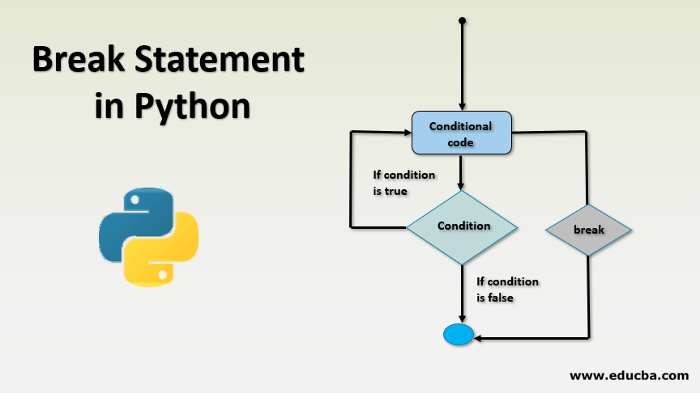

continue Statement
The continue statement skips the current step and moves to the next. It made the loop flexible by ignoring certain conditions.
Example:
for i in range(1, 6):
if i == 3:
continue
print(i)
Output:
1
2
4
5

pass Statement
The pass statement does nothing but acts like a placeholder. At first, it felt useless, but later I understood it helps when we are writing code structure but not ready with the full logic.
Example:
for i in range(5):
pass
Module-III
Introduction to Functions: Declaration and Definition, Variable Scope and Lifetime, Return Statements, Types of Arguments, Lambda function, Recursion
Introduction
In this module, I learned about functions in Python, which are one of the most important building blocks of programming. A function is like a mini-program inside a bigger program. At first, I found the rules and different types of arguments a bit confusing, but as I practiced, I realized functions make code simple, reusable, and easy to maintain.
Understanding Functions
I understood that a function is a block of organized code that performs a specific task. Functions reduce repetition because instead of writing the same logic again and again, we can write it once and call it whenever needed.
Python has two types of functions:
- Built-in functions like print(), len(), input().
- User-defined functions created by programmers using the def keyword.
This made me realize that functions bring modularity to programs, meaning large tasks can be divided into smaller tasks.
1. Built-in Functions
- Built-in functions in Python are the functions that are already provided by Python itself.
- They are designed to perform common tasks like printing, taking input, finding length, type checking, mathematical operations, etc.
Examples of Built-in Functions
- print() → displays output.
- input() → takes input from the user.
- len() → finds length of a list, string, or collection.
- type() → tells the data type of a variable.
- max() and min() → find the largest and smallest value.
- sum() → adds all numbers in a list.
Commonly Used Built-in Functions
- print() – Displays output on the screen.
print("Hello, Python")
- input() – Takes input from the user as a string.
name = input("Enter your name: ")
print("Welcome,", name)
- len() – Returns the length of a string, list, or collection.
fruits = ["apple", "banana", "cherry"]
print(len(fruits))
Output: 3
- type() – Shows the data type of a variable.
x = 10
print(type(x))
Output: <class 'int'>
- max() and min() – Find the largest and smallest values.
numbers = [5, 8, 2, 10]
print(max(numbers))
print(min(numbers))
- sum() – Adds all elements in a list or tuple.
marks = [50, 60, 70]
print(sum(marks))
- range() – Generates a sequence of numbers, useful in loops.
for i in range(1, 6):
print(i)
- abs() – Returns the absolute (positive) value.
print(abs(-7))
- round() – Rounds a number to the nearest integer or given decimal place.
print(round(3.14159, 2))
- sorted() – Returns a sorted list.
nums = [4, 1, 3, 2]
print(sorted(nums))
2.User-defined functions
- User-defined functions are the functions that we create ourselves in Python to perform specific tasks.
- Unlike built-in functions (which are already provided by Python), user-defined functions are written by programmers when they need to reuse some logic multiple times.
- They help make the program organized, reusable, and easy to understand.
Example:
Input:
def greet():
print("Hello, welcome to Python!")

greet()
Output:
Hello, welcome to Python!
Benefits of Functions
- Code Reusability
  - Functions let us write code once and use it many times.
  - Example: If we write an add(a, b) function, we can use it in multiple programs without rewriting the logic.
- Code Simplification
  - Large programs become easier to manage when divided into small functions.
  - Each function performs a specific task, which makes the program clean and understandable.
- Easy Debugging and Testing
  - If there is an error, we can test a single function separately instead of checking the whole program.
  - This makes debugging easier and faster.
- Improved Readability
  - Functions with proper names (like calculate_area() or is_prime()) make the program self-explanatory.
  - Anyone reading the code can easily understand what it does.
- Teamwork and Collaboration
  - In big projects, different programmers can work on different functions.
  - Later, all functions can be combined into one program.
- Avoids Repetition
  - Instead of writing the same set of statements multiple times, we can just call the function whenever required.
  - This saves time and effort.
- Flexibility with Arguments and Return Values
  - Functions can take inputs (parameters) and give back results (return).
  - This makes them very flexible for solving a variety of problems.

Example to Show Benefits
def factorial(n):
if n == 0:
return 1
return n * factorial(n-1)

# We can reuse this function in many places
print(factorial(5)) # 120
print(factorial(7)) # 5040
Function Declaration and Definition
Function:
A function in Python is a block of reusable code that performs a specific task. It helps make the program shorter, cleaner, and easier to understand.
Function Declaration
- In some programming languages (like C or Java), functions are first declared (name, return type, and parameters are introduced) before being defined.
- In Python, we usually do not write a separate declaration.
- The declaration and definition happen together when we use the def keyword.
Function Definition
- A function definition tells Python what the function should do.
- It includes the function name, parameters, body (statements), and an optional return statement.
Syntax:
def function_name(parameters):
"""Optional docstring explaining the function"""
# function body
return value
Example 1: Function without Parameters
def greet():
print("Hello, welcome to Python!")
greet()
Output:
Hello, welcome to Python!
Example: Function with Parameters and Return
def add(a, b):
return a + b
result = add(5, 3)
print(result)
Output:
8
Variable Scope and Lifetime
Variable:
- A variable is like a container or storage location in a program that holds some data (value).
- It is a name that refers to a value stored in the computer’s memory.
- Variables make it possible to store, update, and use data in programs.
Rules for Variables in Python
- A variable name can contain letters, digits, and underscores.
- It cannot start with a digit.
- Variable names are case-sensitive (Age and age are different).
- Keywords like if, while, class cannot be used as variable names.
Example of Variables
x = 10
name = "Ravi"
pi = 3.14
is_active = True
print(x, name, pi, is_active)
Output:
10 Ravi 3.14 True
Types of Variables
- Local Variable – defined inside a function, used only there.
- Global Variable – defined outside functions, can be used anywhere in the program.
1.Local Variable
- A local variable is a variable that is declared inside a function.
- It can be used only within that function.
- Its lifetime ends when the function finishes execution.
Example:
def show():
x = 10
print("Inside function:", x)
show()
print(x)
Global Variable
- A global variable is declared outside all functions.
- It can be used anywhere in the program, inside or outside functions.
- It exists for the entire lifetime of the program.
Example:
x = 50
def display():
print("Inside function:", x)
display()
print("Outside function:", x)
Output:
Inside function: 50
Outside function: 50
Return Statement
- A return statement is used in a function to send a value back to the place where the function was called.
- If a function does not have a return statement, it automatically returns None.
- With return, a function can give results, expressions, or multiple values back to the caller.
Syntax
def function_name(parameters):
# function body
return value
Examples
1. Function Returning a Value
def add(a, b):
return a + b
result = add(5, 3)
print(result)
Output:
8
2. Function Without Return
def greet(name):
print("Hello,", name)

result = greet("Ravi")
print(result)
Output:
Hello, Ravi
None
3. Function Returning Multiple Values
def calculate(a, b):
return a+b, a-b, a*b
x, y, z = calculate(10, 5)
print(x, y, z)
Output:
15 5 50
Types of Arguments
Positional Arguments
- In positional arguments, the order of values matters.
- The first value goes to the first parameter, the second value to the second parameter, and so on.
Example:
def student_info(name, age):
print("Name:", name)
print("Age:", age)
student_info("Ravi", 20)
Output:
Name: Ravi
Age: 20
Keyword Arguments
- In keyword arguments, we use the parameter name while calling the function.
- The order does not matter because names are used to match values.
Example:
student_info(age=20, name="Ravi")
Output:
Name: Ravi
Age: 20
Default Arguments
- In default arguments, a parameter has a default value.
- If no value is given while calling, Python uses the default.
Example:
def greet(name="User"):
print("Hello,", name)
greet("Ravi")
greet()
Variable-Length Arguments
Sometimes we don’t know how many values will be passed. Python allows two ways:
- *args → Positional variable-length arguments
  - Collects multiple values into a tuple.
def add(*nums):
print(sum(nums))
add(2, 3, 4)
add(5, 10)
- **kwargs → Keyword variable-length arguments
  - Collects multiple keyword arguments into a dictionary.
def show_details(**info):
for key, value in info.items():
print(key, ":", value)
show_details(name="Ravi", age=20, city="Delhi")
Lambda Functions
A lambda is a short unnamed function, useful for small tasks.
Syntax:
lambda args: expression
Examples:
square = lambda x: x * x
print(square(4)) # 16
# sort a list of tuples by second item
pairs = [(1, 'b'), (2, 'a')]
pairs.sort(key=lambda x: x[1])
Use cases: short callbacks for sorted, map, filter, or small one-line operations. For complex logic use def (named function) for readability.
Recursion
Recursion is when a function calls itself. Useful for problems that can be divided into smaller subproblems (like trees, factorial, quicksort).
Example — factorial:
def factorial(n):
if n == 0:
return 1
return n * factorial(n - 1) # recursive case
Important ideas:
- Base case: stops recursion (must exist).
- Progress toward base: each call must move closer to the base case.
- Stack and depth: each recursive call uses stack memory. Python has a recursion limit (default ~1000). Deep recursion can cause RecursionError.
Example — naive Fibonacci (inefficient):
def fib(n):
if n < 2:
return n
return fib(n-1) + fib(n-2)
Higher-Order Functions & First-Class Functions
In Python, functions are first-class — you can pass them as arguments, return them, or store them in variables.
Example:
def apply(func, value):
return func(value)
print(apply(lambda x: x+1, 5))
Module-IV
Features of Object-Oriented Programming: Classes, Objects, Method and Message Passing, Inheritance, Polymorphism, Data Abstraction and Encapsulation, Reusability, Delegation
Introduction
In this module, I learned about Object-Oriented Programming (OOP), which is a style of programming that organizes code around objects rather than just functions. At first, the terms like classes, inheritance, polymorphism, abstraction looked difficult, but as I studied each one, I realized that OOP makes programs structured, reusable, and easier to manage. This module gave me a new way of thinking about solving problems in Python.
Classes and Objects
I understood that a class is like a blueprint, and an object is an actual thing created from that blueprint.
- A class defines properties (attributes) and behaviors (methods).
- An object is an instance of the class.
Example:
class Student:
def __init__(self, name, age):
self.name = name
self.age = age
s1 = Student("Ravi", 20)
print(s1.name)

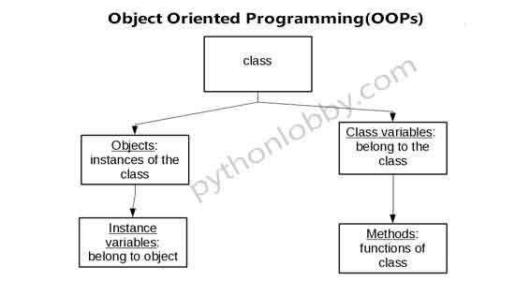
Methods and Message Passing
A method is a function inside a class that works with the object’s data. Message passing happens when an object calls these methods.
class Car:
def start(self):
print("Car started")
c1 = Car()
c1.start() # Message passing
Inheritance
Inheritance allows a new class to take properties and methods from an existing class.
- It promotes reusability.
- Child class can use or modify parent class features.
Example:
class Animal:
def sound(self):
print("Animal makes a sound")
class Dog(Animal):
def sound(self):
print("Dog barks")
d = Dog()
d.sound()

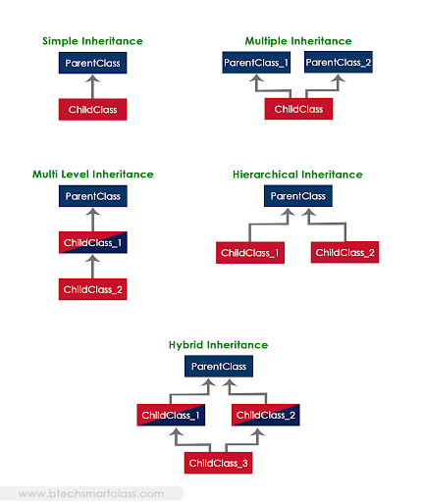
Polymorphism
Polymorphism means “many forms.” In Python, it allows different classes to have methods with the same name but different behavior.
Example:
class Bird:
def move(self):
print("Bird flies")

class Fish:
def move(self):
print("Fish swims")

for animal in (Bird(), Fish()):
animal.move()
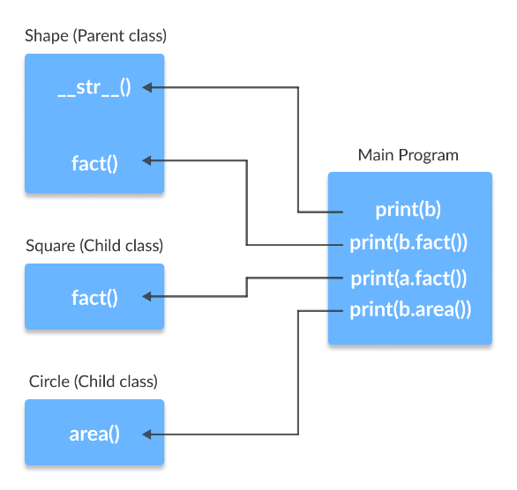
Data Abstraction and Encapsulation
- Abstraction means hiding unnecessary details and showing only what is needed. For example, when we use a len() function, we don’t see the internal logic.
- Encapsulation means wrapping data (variables) and methods into one unit (class). We can also make some data private using _ or __.
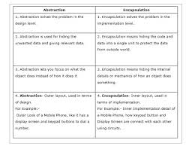
Reusability
I realized that OOP encourages reusability by allowing us to use classes, methods, and inheritance across different projects. This saves time and makes code more efficient.
Delegation
I also learned about delegation, which means an object can hand over a task to another object. Instead of doing everything itself, an object can use another object’s functionality. This reminded me of teamwork, where one person assigns part of a job to someone else.
Module-V
Data Structures: Sequence, Arrays, Vectors, Lists, Tuple, Sets, Dictionaries, Maps
Introduction
In this module, I learned about data structures in Python, which are ways of storing and organizing data. At first, I thought data structures were only used in advanced programming, but soon I realized they are part of almost every program we write. They help manage data more effectively and make problem-solving faster. I studied different types of data structures like sequences, arrays, vectors, lists, tuples, sets, dictionaries, and maps.
Sequences
A sequence is an ordered collection of items. Examples in Python include strings, lists, and tuples.
- Items can be accessed using their index.
- Operations like slicing, length checking, and iteration are possible.
Example:
text = "Python"
print(text[0]) # P
print(text[2:5]) # tho
This showed me how powerful and simple Python makes handling sequences.
Arrays and Vectors
I learned that arrays store multiple values of the same type efficiently. In Python, arrays can be used through the array module or NumPy library.
- Vectors are similar to one-dimensional arrays and are very useful in mathematics, data science, and machine learning.
Example:
import array
nums = array.array('i', [1, 2, 3, 4])
print(nums[1]) # 2
This helped me see how arrays are better than lists for numerical operations.
Lists
A list is one of the most flexible data structures in Python.
- It is ordered, mutable, and can store different data types.
- We can add, remove, or update items easily.
Example:
fruits = ["apple", "banana", "cherry"]
fruits.append("mango")
print(fruits)
I enjoyed working with lists because they are simple and useful in almost all Python programs.
Tuples
A tuple is similar to a list but immutable (cannot be changed once created).
- Tuples are faster than lists.
- They are useful when data must remain fixed.
Example:
colors = ("red", "green", "blue")
print(colors[0]) # red
At first, I didn’t understand why we need tuples, but later I realized they protect data from unwanted changes.
Sets
A set is an unordered collection that stores unique items.
- It removes duplicates automatically.
- It allows mathematical operations like union, intersection, and difference.
Example:
a = {1, 2, 3}
b = {3, 4, 5}
print(a | b) # {1, 2, 3, 4, 5}
print(a & b) # {3}
This reminded me of school mathematics, which made sets easy to understand.
Dictionaries
A dictionary stores data in key–value pairs.
- Keys are unique, and values can be of any type.
- Dictionaries allow fast lookups.
Example:
student = {"name": "Ravi", "age": 20, "course": "Python"}
print(student["name"]) # Ravi
I really liked dictionaries because they work just like real dictionaries: search with a key and get the value.
Maps
In Python, maps are similar to dictionaries, as they connect keys to values. I also learned about the map() function, which applies a function to every element of a sequence.
Example:
nums = [1, 2, 3, 4]
squares = list(map(lambda x: x*x, nums))
print(squares) # [1, 4, 9, 16]
This showed me how maps can make operations simple and fast.
Module-VI
Strings and its operations: Concatenating, Appending, Multiplying strings, Builtin String methods and functions, Slice Operation, Iterating String, String Module
Introduction
In this module, I learned about strings in Python and the different operations that can be performed on them. A string is simply a sequence of characters, and it is one of the most widely used data types in programming. At first, I thought strings were just for storing text, but later I realized they are very powerful because Python provides many built-in operations and methods for handling them.
Mutable V/s Immutable Data Types
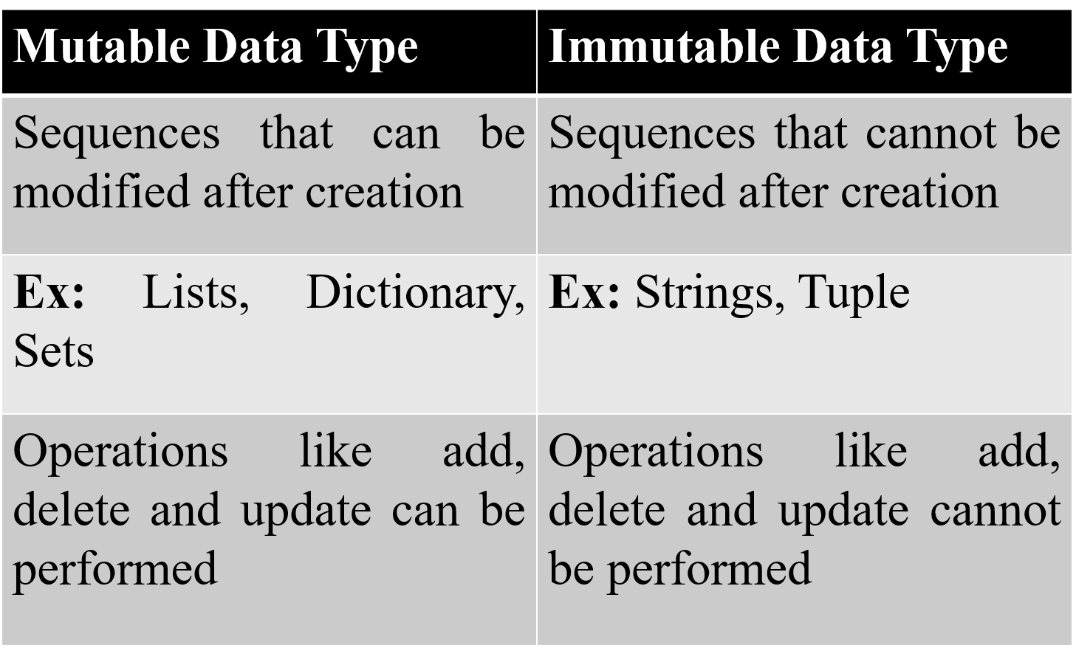
Concatenating Strings
Concatenation means joining two or more strings together using the + operator.
str1 = "Hello"
str2 = "World"
result = str1 + " " + str2
print(result)
This made me realize how easily we can build sentences or messages in programs.
Appending Strings
Appending means adding more content to an existing string. Since strings are immutable, this is usually done by creating a new string.
text = "Python"
text = text + " Programming"
print(text)
Multiplying Strings
Python allows us to multiply strings using the * operator, which repeats the string multiple times.
print("Hi! " * 3)
Output:
Hi! Hi! Hi!
This was surprising at first but useful for patterns and formatting.
Formatting Symbols
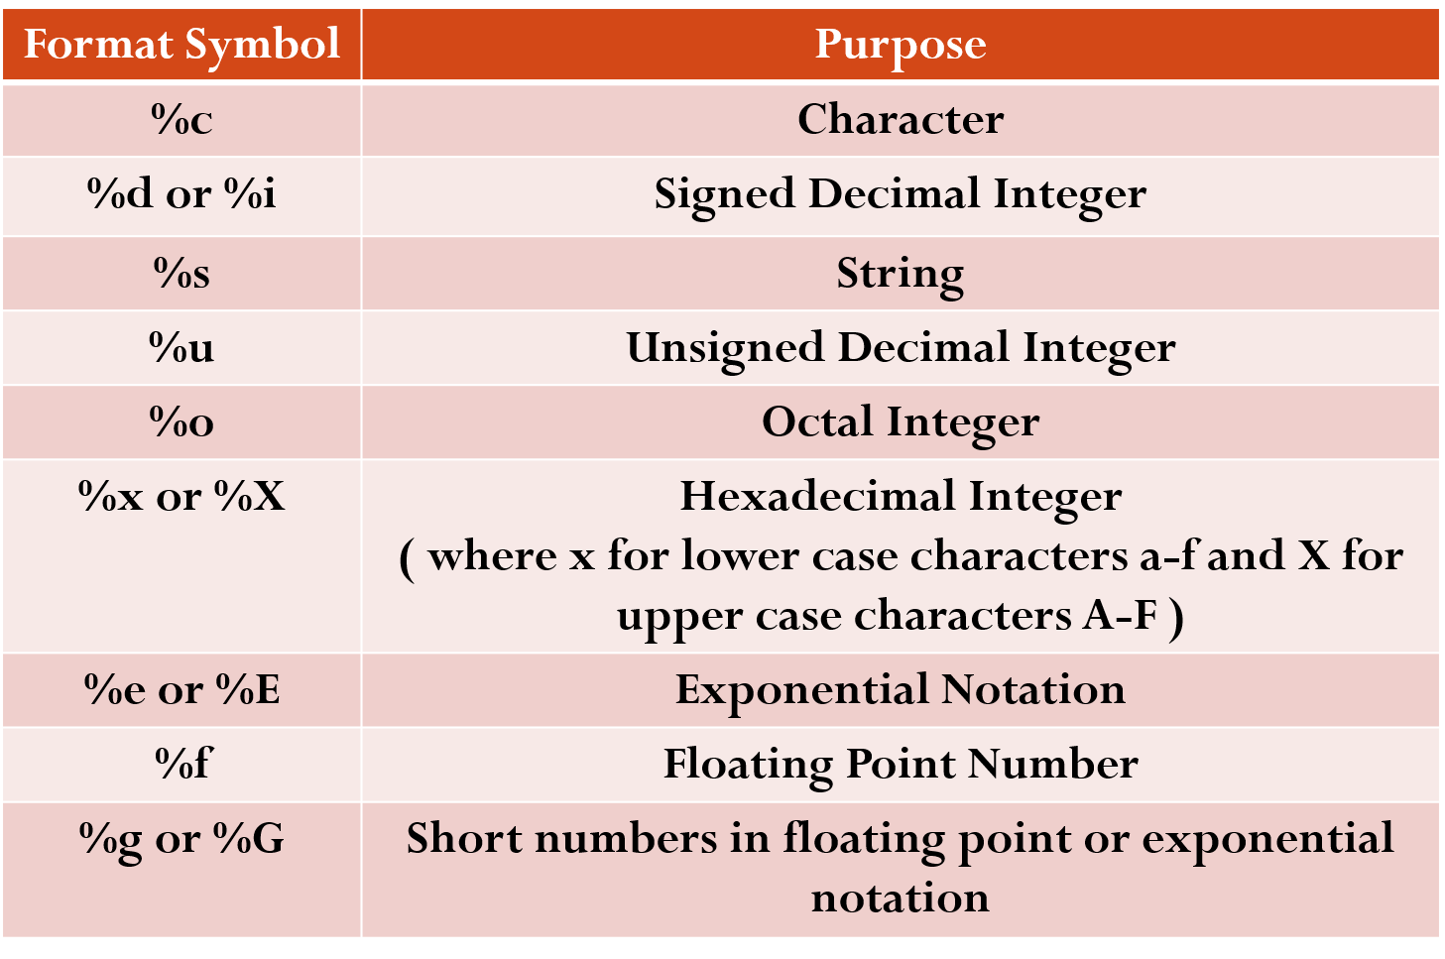
Built-in String Methods and Functions
I explored many built-in string methods such as:
- upper() → converts to uppercase.
- lower() → converts to lowercase.
- strip() → removes extra spaces.
- replace() → replaces part of a string.
- split() → breaks a string into a list.
- find() → finds the position of a substring.
Example:
text = " Hello Python "
print(text.strip().upper()) # HELLO PYTHON
These methods made me realize how powerful and convenient Python is for text handling
Slice Operation
Slicing allows us to extract parts of a string using indices.
word = "Programming"
print(word[0:6]) # Progra
print(word[-3:]) # ing
Slicing helped me understand that strings can be handled like sequences.
Iterating a String
A string can be looped character by character using a for loop.
for ch in "Python":
print(ch)
This operation made me think about how programs process each character individually, for example in password checking.
String Module
I also discovered the string module, which provides useful constants and functions. Examples include:
- string.ascii_letters → all letters (a–z, A–Z).
- string.digits → all numbers (0–9).
- string.punctuation → all special symbols.
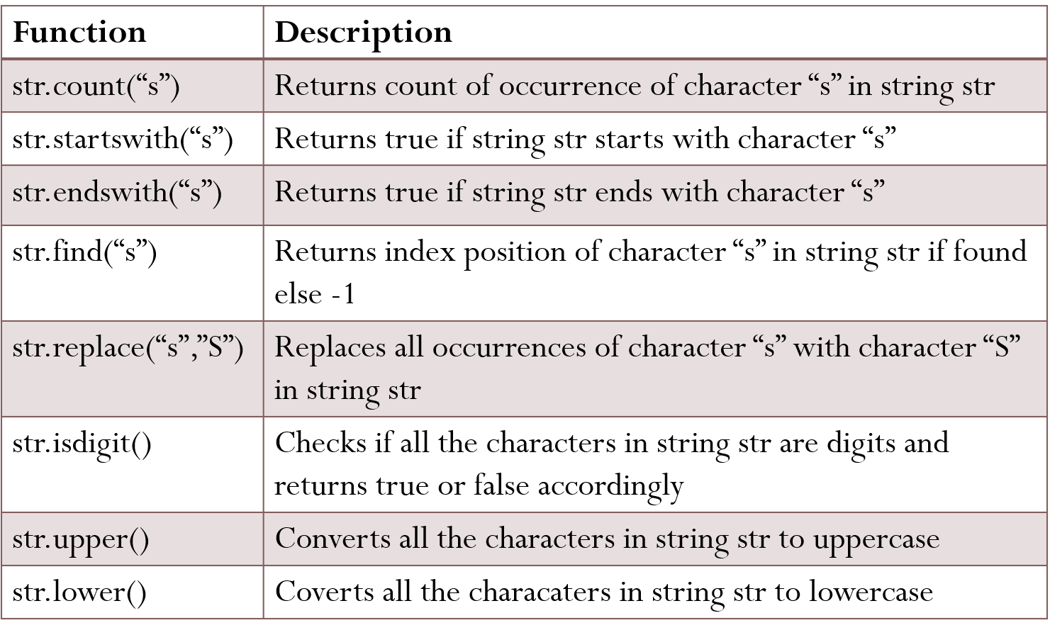
Example:
import string
print(string.digits)
print(string.punctuation)
This gave me more tools for text processing and validation.

Module-VII
Multithreading: Introduction to Thread, Advantages, Lifecycle of a Thread, Threading Module and its Methods
Error and Exceptional Handling: Introduction to Errors and Exceptions, Types of Errors,
Types of Exceptions, Multiple Except Blocks, Raising Exceptions Builtin and Userdefined Exceptions
Introduction
Module VII introduced me to two powerful programming concepts: Multithreading and Error/Exception Handling. These are essential in making programs not only efficient but also reliable. Threads allow multiple tasks to be executed simultaneously, while exception handling ensures programs can deal with unexpected situations without crashing. In this essay, I will reflect on the knowledge I gained, along with examples that illustrate how these concepts work in Python.
Introduction to Thread
A thread is the smallest unit of execution in a program. It represents a single sequence of instructions that can run independently but shares the same resources (like memory) with other threads in the same process. In simple terms, a thread is like a lightweight process that allows multiple tasks to be performed at the same time within a single program.
For example, in a web browser, one thread may load a webpage, another may play a video, while a third handles user input—all running together without blocking each other.
Threads are useful because they enable multitasking and make applications more responsive. In Python, threads can be created and managed using the threading module, which provides methods to start, pause, and stop threads.

Multithreading
Introduction to Thread
A thread is the smallest unit of execution within a program. Multiple threads can run concurrently in the same process, sharing memory and resources.
Example:
import threading
def task():
print("Thread is running")
# Creating a thread
t = threading.Thread(target=task)
t.start()
t.join()
Here, the function task() runs in a separate thread, showing how easily Python allows concurrent execution.
Advantages of a Thread
Threads are widely used because they provide many advantages:
- Improved Performance – Tasks run in parallel.
- Responsiveness – Programs don’t freeze during long tasks.
- Resource Sharing – Multiple threads share memory.
- Better CPU Utilization – Useful in multi-core systems.
- Simplified Program Design – Easier handling of tasks like multiple clients in a server.
Example:
import threading
import time
def download():
for i in range(3):
print("Downloading file", i+1)
time.sleep(1)
def print_task():
for i in range(3):
print("Printing page", i+1)
time.sleep(1)
t1 = threading.Thread(target=download)
t2 = threading.Thread(target=print_task)
t1.start()
t2.start()
t1.join()
t2.join()
Both downloading and printing run together without waiting for each other.
Lifecycle of a Thread
A thread passes through several states:
- New (Created) – Thread object created but not started.
- Runnable – Thread ready to run, waiting for CPU.
- Running – CPU is executing the thread.
- Waiting/Blocked – Thread paused, waiting for event/resource.
- Terminated/Dead – Thread has finished.
Example:
import threading, tim
def worker():
print("Thread running...")
time.sleep(2)
print("Thread finished.")
t = threading.Thread(target=worker)
print("Thread created (New)")
t.start() # Runnable -> Running
print("Thread started")
t.join() # Waits until thread finishes
print("Thread terminated")
Threading Module and its Methods
Python’s threading module provides methods to manage threads:
- Thread() → Creates thread object.
- start() → Starts execution.
- run() → Defines the work of a thread.
- join() → Waits for completion.
- is_alive() → Checks if thread is running.
- current_thread() → Returns current thread object.
- enumerate() → Lists active threads.
Example:
import threading
import time
def task():
time.sleep(1)
print(f"Running: {threading.current_thread().name}")
t = threading.Thread(target=task, name="MyThread")
t.start()
print("Is thread alive?", t.is_alive())
t.join()
print("Is thread alive after join?", t.is_alive())
Error and Exception Handling
Introduction to Errors and Exceptions
Errors and exceptions are problems that occur during the execution of a program.
- Errors are usually serious problems, such as syntax mistakes, which stop the program.
- Exceptions are events that disrupt the normal flow of execution but can be handled gracefully.
Instead of crashing, Python provides mechanisms to catch and handle exceptions, making programs more user-friendly.
Example (without handling):
print(10/0) # ZeroDivisionError
Example (with handling):
try:
print(10/0)
except ZeroDivisionError:
print("Error: Cannot divide by zero")
Types of Errors
- Syntax Errors – Wrong code format.
- print("Hello" # Missing parenthesis
- Logical Errors – Wrong output due to faulty logic.
- # Expected square but prints cube
- num = 3
- print(num ** 3)
- Runtime Errors – Occur during execution.
- x = int("abc") # ValueError

Types of Exceptions
Exceptions are events that occur during program execution and disrupt the normal flow of instructions. Python has many built-in exceptions to handle different types of errors. Some of the most common ones are:

1. ZeroDivisionError
Occurs when a number is divided by zero.
Example:
try:
result = 10 / 0
except ZeroDivisionError:
print("Error: Division by zero is not allowed.")

2. IndexError
Occurs when trying to access an index that does not exist in a list.
Example:
try:
numbers = [1, 2, 3]
print(numbers[5]) # Invalid index
except IndexError:
print("Error: List index out of range.")

3.KeyError
Occurs when trying to access a key that does not exist in a dictionary.
Example:
try:
student = {"name": "John", "age": 20}
print(student["grade"]) # Key not present
except KeyError:
print("Error: Key not found in dictionary.")

4. FileNotFoundError
Occurs when trying to open a file that does not exist.
Example:
try:
file = open("data.txt", "r") # File not available
except FileNotFoundError:
print("Error: The file does not exist.")

5. ValueError
Occurs when an operation receives a value of the right type but inappropriate content.
Example:
try:
num = int("abc") # Cannot convert string to int
except ValueError:
print("Error: Invalid value.")
Multiple Except Blocks
We can handle different exceptions with separate except blocks.
Example:
try:
num = int(input("Enter number: "))
result = 10 / num
except ValueError:
print("Invalid input! Enter a number.")
except ZeroDivisionError:
print("Cannot divide by zero.")
Raising Exceptions
We can raise exceptions manually using raise.
Example:
x = -10
if x < 0:
raise ValueError("Number must be positive!")
Built-in and User-Defined Exceptions
Built-in Example:
try:
x = int("abc")
except ValueError as e:
print("Built-in Exception:", e)
User-Defined Example:
class MyException(Exception):
pass
try:
raise MyException("This is a user-defined exception.")
except MyException as e:
print("Caught:", e)
Module-VIII
File Handling: Types of files, Opening, Closing, Reading, Writing, Merge Operations on files

Introduction
File Handling is an important concept in Python that allows us to work with files stored on the computer. Using file handling, we can create, open, read, write, and modify files. Files are useful for storing data permanently, unlike variables that store data temporarily in memory.
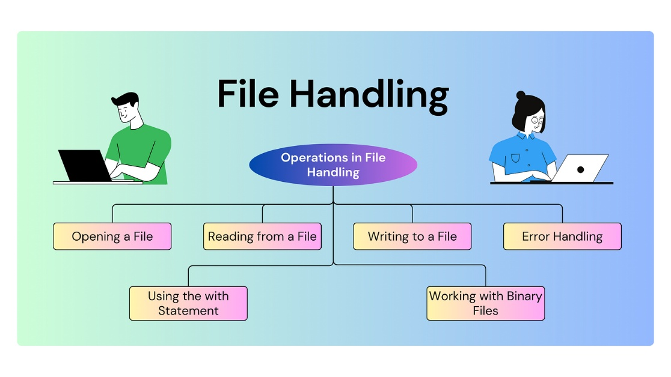
Types of Files
There are mainly two types of files:
- Text Files (.txt)
  - Store data in human-readable format (plain text).
  - Each line in the file is terminated by a newline character \n.
  - Example: student records, configuration files.
Example content of a text file:
Name: John
Age: 21
Course: BCA
- Binary Files (.bin, .dat, images, etc.)
  - Store data in binary (0s and 1s).
  - Not human-readable, used for images, videos, and executables.
  - Requires special methods for reading and writing.
Opening and Closing Files
Python provides the open() function to open files.
Syntax:
file = open("filename", "mode")
Modes of Opening Files:
- "r" → Read mode (default).
- "w" → Write mode (creates a new file or overwrites existing).
- "a" → Append mode (adds new data to the end of the file).
- "b" → Binary mode.
- "t" → Text mode (default).
- "x" → Exclusive creation (error if file exists).
Closing a File:
file.close()
Example:
f = open("demo.txt", "w")
f.write("Hello, File Handling!")
f.close()
Reading from a File
Methods to read data:
- read() → Reads entire file.
- read(n) → Reads first n characters.
- readline() → Reads one line at a time.
- readlines() → Reads all lines into a list.
Example:
f = open("demo.txt", "r")
print(f.read()) # Reads whole file
f.close()
f = open("demo.txt", "r")
print(f.readline()) # Reads one line
f.close()
Writing to a File
- write() → Writes string data into a file.
- writelines() → Writes a list of strings into a file.
Example:
f = open("demo.txt", "w")
f.write("Python is easy.\n")
f.write("File handling is powerful.\n")
f.close()
Appending Data:
f = open("demo.txt", "a")
f.write("This line is added later.\n")
f.close()
Merge Operations on Files
We can combine contents of two or more files into a single file.
Example: Merging Two Files
f1 = open("file1.txt", "r")
f2 = open("file2.txt", "r")
f3 = open("merged.txt", "w")
# Write content of file1
for line in f1:
f3.write(line)
# Write content of file2
for line in f2:
f3.write(line)
f1.close()
f2.close()
f3.close()
This program merges file1.txt and file2.txt into a new file merged.txt.
Module-IX
Modules and Packages:
Builtin modules User Defined modules Overview of NumpyArrays, Array indexing, Datatypes, Array math, Broadcasting, Scipy Image operations, PandasDataframe operations, Seaborn
Introduction
In Python, modules and packages allow us to organize and reuse code efficiently. Instead of writing code repeatedly, we can place functions, classes, or variables inside a module and use them in multiple programs. Packages are collections of related modules stored in a directory structure. Additionally, Python has many scientific and data analysis libraries such as NumPy, SciPy, Pandas, and Seaborn which make it powerful for research and real-world applications.
Built-in Modules
Python comes with many modules already installed, such as:
- math – mathematical functions.
- random – random number generation.
- datetime – date and time manipulation.
- os – operating system operations.
- sys – system-specific parameters and functions.
Example:
import math
print("Square root of 25 is:", math.sqrt(25))
import random
print("Random number:", random.randint(1, 10))
User-Defined Modules
We can create our own modules by saving functions in a .py file.
Example (mymodule.py):
def greet(name):
return f"Hello, {name}!"
Using the module in another file:
import mymodule
print(mymodule.greet("John"))
NumPy Overview
NumPy (Numerical Python) is used for scientific computing. It provides a powerful array object which is faster than Python lists.
NumPy Arrays
import numpy as np
arr = np.array([1, 2, 3, 4])
print("Array:", arr)
Array Indexing
arr = np.array([10, 20, 30, 40, 50])
print(arr[0]) # First element
print(arr[-1]) # Last element
Data Types
arr = np.array([1, 2, 3], dtype='float32')
print(arr.dtype)
Array Math
arr1 = np.array([1, 2, 3])
arr2 = np.array([4, 5, 6])
print("Addition:", arr1 + arr2)
print("Multiplication:", arr1 * arr2)
Broadcasting
Broadcasting allows operations between arrays of different shapes.
arr = np.array([1, 2, 3])
print(arr + 10) # Adds 10 to each element
SciPy Overview
SciPy builds on NumPy and is used for scientific and engineering calculations.
Image Operations with SciPy
from scipy import misc
import matplotlib.pyplot as plt
# Load example image
face = misc.face()
plt.imshow(face)
plt.show()
Pandas Overview
Pandas is used for data analysis and manipulation. Its main structure is the DataFrame (like a table).
Creating a DataFrame
import pandas as pd
data = {"Name": ["John", "Alice", "Bob"],
"Age": [25, 30, 22]}
df = pd.DataFrame(data)
print(df)
DataFrame Operations
print(df.head()) # First rows
print(df["Name"]) # Access column
print(df.describe()) # Summary statistics
Seaborn Overview
Seaborn is a visualization library built on Matplotlib, designed for statistical graphics.
Example:
import seaborn as sns
import matplotlib.pyplot as plt
tips = sns.load_dataset("tips")
sns.barplot(x="day", y="total_bill", data=tips)
plt.show()
This produces a bar plot showing average total bills per day.
Module-X
Plotting Graphs in Python: Matplotlib , Plotting, Subplots, Images
GUI Programming with tkinter package, Simple Graphics using Turtle, Plotting graphs in python
Introduction
Visualization and graphical interfaces are important in modern programming. This module introduces:
- Plotting Graphs in Python using Matplotlib.
- GUI Programming with the tkinter package.
- Simple Graphics using the Turtle module.
These tools make Python more interactive and useful for real-world applications such as data visualization, user interface development, and graphical design.
Plotting Graphs in Python – Matplotlib
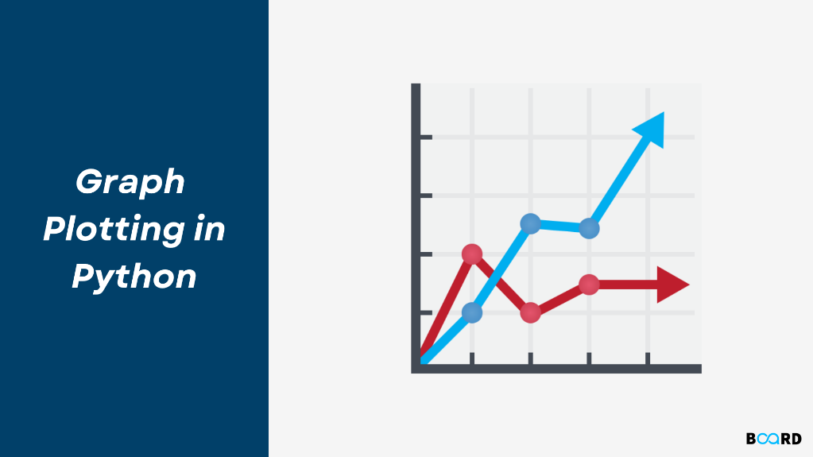
1. Plotting Graphs in Python (with Matplotlib)
Matplotlib is a powerful library in Python used for creating different types of graphs like line plots, bar graphs, scatter plots, histograms, and pie charts.
Syntax:
import matplotlib.pyplot as plt
plt.plot(x, y) # for line plot
plt.xlabel("X-axis") # label x-axis
plt.ylabel("Y-axis") # label y-axis
plt.title("Graph") # title of graph
plt.show() # display graph

2. Plotting - GUI Programming with tkinter
tkinter is the standard Python library for creating Graphical User Interfaces (GUIs). It can also display simple plots when combined with matplotlib or Canvas.
Syntax (basic GUI window):
import tkinter as tk
root = tk.Tk()
root.title("My GUI")
root.geometry("300x200")
label = tk.Label(root, text="Hello GUI")
label.pack()
root.mainloop()
3. Subplots (in Matplotlib)
Subplots allow us to display multiple graphs in a single figure (window).
Syntax:
import matplotlib.pyplot as plt
fig, axs = plt.subplots(2, 2)
axs[0, 0].plot(x, y)
axs[0, 1].bar(x, y)
axs[1, 0].scatter(x, y)
axs[1, 1].hist(y)
plt.show()

4. Simple Graphics using Turtle
turtle is a Python module for simple graphics and drawings. It works like moving a pen around on the screen.
Syntax:
import turtle
t = turtle.Turtle()
t.forward(100)
t.left(90)
t.forward(100)
turtle.done()

5. Images - Plotting Graphs in Python (with Matplotlib)
Matplotlib can also display images along with graphs using imshow().
Syntax:
import matplotlib.pyplot as plt
import matplotlib.image as mpimg
img = mpimg.imread("myimage.png")
plt.imshow(img)
plt.axis("off")
plt.show()

Widgets and Their Methods
Label:
- Label(master, text, font): Create a text label
- pack(): Places the label in the window
Button:
- Button(master, text, command): Creates a button with a command
Entry:
- Entry(master): Creates a text entry box
- get(): Retrieves input
syntax:
import tkinter as tk
# Create main window
root = tk.Tk()
root.title("Widgets Example")
root.geometry("300x200")
# Function for button action
def show_text():
user_input = entry.get() # get text from entry box
label_result.config(text="You typed: " + user_input)
# Label
label = tk.Label(root, text="Enter something:", font=("Arial", 12))
label.pack(pady=5)
# Entry
entry = tk.Entry(root)
entry.pack(pady=5)
# Button
button = tk.Button(root, text="Show", command=show_text)
button.pack(pady=5)
# Result Label
label_result = tk.Label(root, text="", font=("Arial", 12))
label_result.pack(pady=5)
# Run the GUI
root.mainloop()
Customizing the Turtle
turtle graphics allow you to control the pen’s color, shape, speed, and movement to create customized drawings.
Syntax:
import turtle
t = turtle.Turtle()
t.shape("turtle")
t.color("blue")
t.pensize(3)
t.speed(5)
# Draw a square
for i in range(4):
t.forward(100)
t.right(90)
turtle.done()

2. Bar Charts (Matplotlib)
A bar chart represents categorical data with rectangular bars (heights show values).
Syntax:
import matplotlib.pyplot as plt
x = ["A", "B", "C", "D", "E"]
y = [5, 7, 3, 8, 4]
plt.bar(x, y, color="skyblue", width=0.5, edgecolor="black")
plt.xlabel("Categories")
plt.ylabel("Values")
plt.title("Customized Bar Chart")
plt.show()

3. Scatter Plot (Matplotlib)
A scatter plot shows the relationship between two sets of data using points.
Syntax:
import matplotlib.pyplot as plt
x = [5, 7, 8, 7, 6, 9, 5]
y = [99, 86, 87, 88, 100, 86, 103]
plt.scatter(x, y, color="red", marker="*", s=100) # s=point size
plt.xlabel("X values")
plt.ylabel("Y values")
plt.title("Customized Scatter Plot")
plt.show()

4. Histogram (Matplotlib)
A histogram shows the frequency distribution of a dataset (how often values fall into ranges/bins).
Syntax:
import matplotlib.pyplot as plt
data = [22, 87, 5, 43, 56, 73, 55, 54, 11, 20, 51, 5, 79, 31, 27]
plt.hist(data, bins=5, color="green", edgecolor="black") # bins = no. of intervals
plt.xlabel("Value Ranges")
plt.ylabel("Frequency")
plt.title("Customized Histogram")
plt.show()

